IMPORTANT! IMPORTANT! IMPORTANT!

Parents,

ALL families must register for the St. Cajetan School website. Below are specific directions for signing up. It is very important to understand that **if you do not register your email address, you will not receive news alerts from the school** and this will be the main source of communication for Mrs. Nitsche. You also have the option to register your phone number so you can receive alerts directly to you cell phone. If you are having difficulty registering, please send an email to [**webmaster@cajetan.org**](mailto:webmaster@cajetan.org).

-------------------------------------------------------------------------------------------------------------------------------------------

**Step 1:** Go to [**www.stcajetanschool.org**](http://www.stcajetanschool.org)**.**

**Step 2:**  Click on “Parents” in the menu bar. This should bring you to the photo shown below.

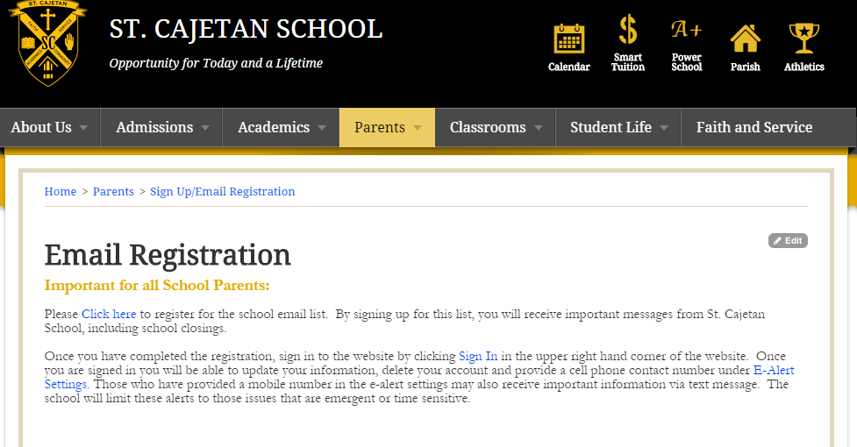

**Step 3:** Once you **“Click here”** to begin registering, you will be directed to enter your birthday.

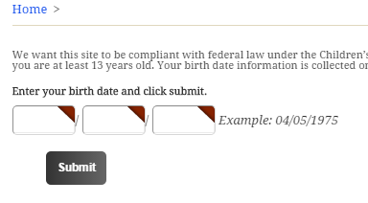

**Step 4:** Next you will be directed to a screen that will ask you to add some important information including

your email. It will also ask you to create a username and password. This will be the username and

password you will use to log in to secure areas so choose something you can remember.

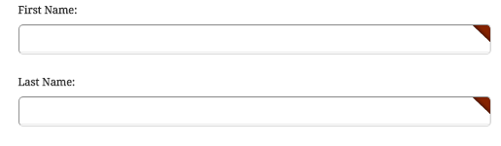



**Step 5-** Not done yet! Now you need to sign-in so you can register your cell phone number so you can receive

text alerts.

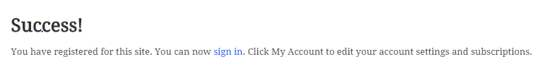

**Step 6-** Go ahead and sign in again and on this screen you will be able to update your information, including

Providing a cell phone contact number under E- Alert setting. **Those who have provided a mobile**

**number in the E-Alert settings will also receive important information via text message**. If you do not

add a cell phone on this specific page, you will NOT receive text updates.

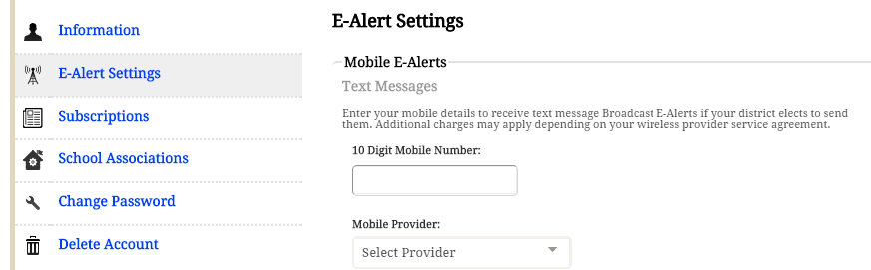

***FYI***- You can change your account settings at anytime by clicking on “**My Accounts**.”

